1. Block Down
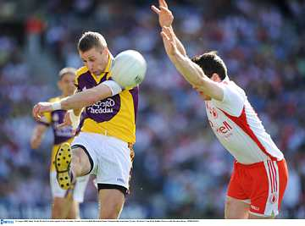

- Introduce
- Demonstrate
- Execute
- Attend

The Block Down is a tackling technique used to prevent the opponent shooting or passing to another player. In scoring situations the Block Down is an effective and dramatic defensive skill

Stand close to the opponent in the check position

Reach forward arms outstretched as the opponent prepares to play the ball.
Look out for:
- Shying away from contact
- Missing the ball
- Closing the eyes

Block ball at point of contact with the boot
Pg. 55-60 FFD

Block Down

Practice the Technique


Partner Block
Player A toe taps the ball for player B in a kneeling position to Block Down

Zig-Zag Block
One player moves from cone to cone and tries to Block each player
Hit the Target
A passes to B, who rounds the cone and passes to D while C tries to Block Down

Develop the Skill


Grid Block
Team retain possession by kick passing while the other team tries to gain possession by Blocking down
Shoot and Block II
Attacker solos to goal, when they attempt to shoot the defender tries to Block them



